Naive Bayes Theorem
Let’s first look at what’s probability:
Probability is always quantified as a percentage or a number between 0 and 1. The probability can either be a discrete or a continuous variable. Coin flipping is a perfect example for explaining Probability. The chances of seeing ‘head’ when a coin is flipped: ½ or 0.5
Conditional Probability:
Probability of event A given event B already happened is the probability of event B with event A already happened times probability of A and dividing this with probability of B.
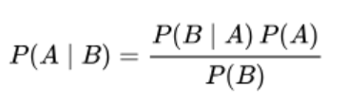

Naive Bayes methods are a set of supervised learning algorithms based on applying Bayes' theorem with the “naive” assumption of conditional independence between every pair of features given the value of the class variable. It was initially introduced for text categorisation tasks and still is used as a benchmark.
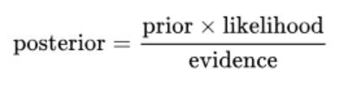
Uses:
It was initially introduced for text categorisation tasks and still is used as a benchmark.
There have been many innovations like Support Vector Machines or KNN over the years in solving the classification problem with more flexibility and smartly. But Naive Bayes classifier can still be competent with enough pre-processed data and has shown great results in medical applications where classification is crucial in diagnosis.
Example:
